2.2 In the Fig.2.2.1 the app ‘Blood Banks India Directory’ displays only the Blood Banks.

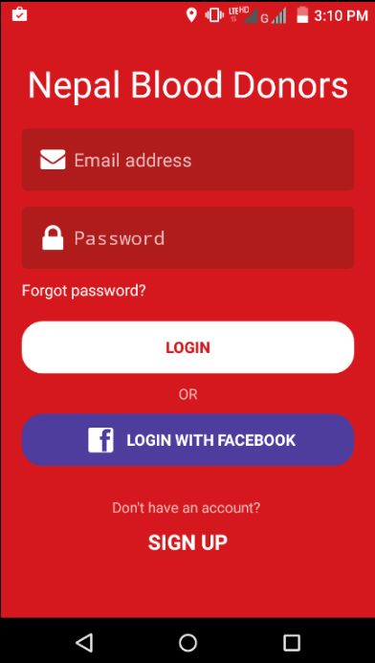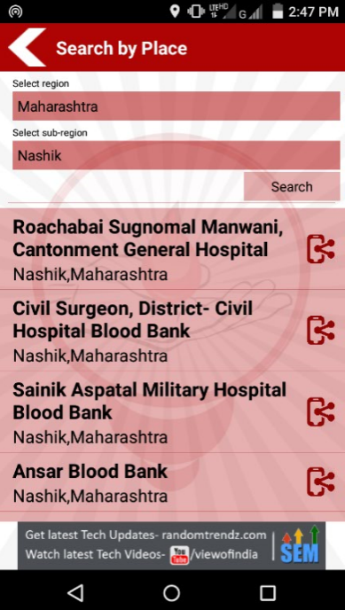 In the Fig.2.2.2 the app ‘Nepal Blood Donors’ requires email ID and the password or our Facebook account which loses security.

Fig.2.2.1: Screenshot of Blood Banks India Directory Fig.2.2.2: Screenshot of Nepal Blood Donors